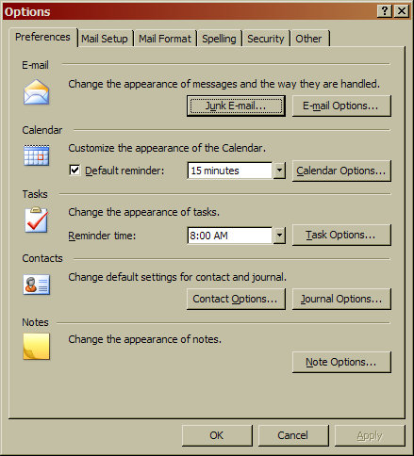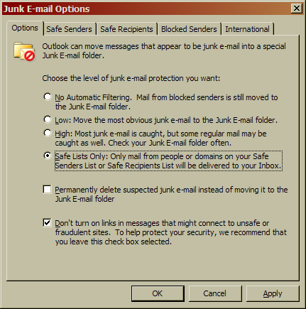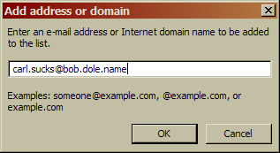
Summary
I don’t use Outlook (I use Gmail), so I wasn’t exactly able to test it, but if that was Carl’s e-mail address, I’m sure he could send me mail. I have a raging sea of spam in Gmail though – 6520 messages right now. So I think the filter is working great, since I don’t get any spam in my inbox. Or, at least, I rarely do. Anyways, this is probably a good thing to do if you actually use Outlook.

